|  |  |  |  |
| --- | --- | --- | --- |
| **ID: 1** | **Story Title: Sign In** | **Priority: 1** | **Estimate: 2 h** |
| Sign In, so the user gets access to user account. | | | |

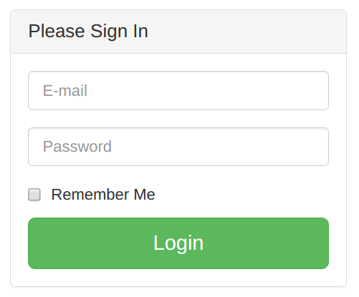

**Confirmation:**

1. **Success** – valid user sign in and directed to home page
   1. User introduced with the homepage, and have all access to options of golf handicap app.
2. **Failure** – display message
   1. E-mail and user password did not match against stored data in the database.
   2. Failed message displayed.

|  |  |  |  |
| --- | --- | --- | --- |
| **ID: 2** | **Story Title:**  **Sign Up** | **Priority: 1** | **Estimate: 2 h** |
| Sign Up, add a new user to the system. | | | |

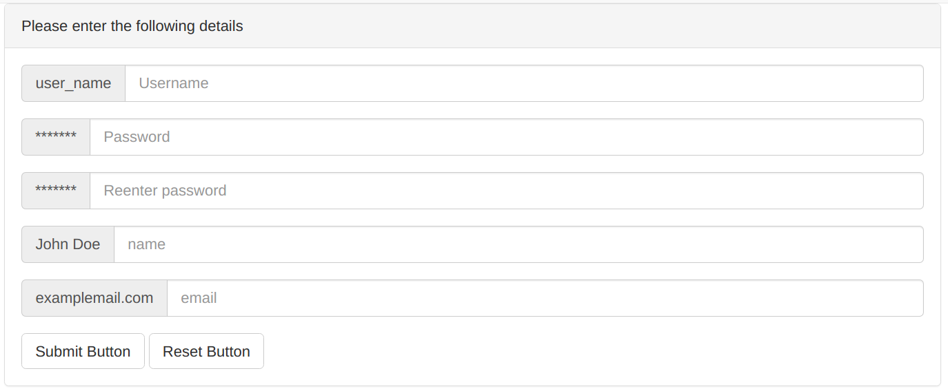

**Confirmation:**

1. **Success** – new user sign up and added to the system and can sign into account
   1. User added to the system, and have access to options of golf handicap app.
2. **Failure** – display message
   1. Users detail not passed validity test and cannot be stored in the database.
   2. Failed message displayed.

|  |  |  |  |
| --- | --- | --- | --- |
| **ID: 3** | **Story Title:**  **Update User** | **Priority: 4** | **Estimate: 2 h** |
| Update user details per new requirements. | | | |

**Confirmation:**

1. **Success** – details of user updated and stored in database
   1. User details i.e. username, is updated and successfully stored in database
2. **Failure** – display message
   1. Users detail not passed validity test and cannot be stored in the database.
   2. Failed message displayed.

|  |  |  |  |
| --- | --- | --- | --- |
| **ID: 4** | **Story Title:**  **Delete User** | **Priority: 4** | **Estimate: 2 h** |
| Remove user from the system. | | | |

**Confirmation:**

1. **Success** – user deleted from system per request or violation of rules.
   1. User does not wish to keep his details in the system and successfully deleted from system and database
2. **Failure** – display message
   1. Users detail have not been found in the current database.
   2. Failed message displayed.

|  |  |  |  |
| --- | --- | --- | --- |
| **ID: 5** | **Story Title:**  **List User Data** | **Priority: 5** | **Estimate: 2 h** |
| List the detail of the particular user. | | | |

**Confirmation:**

1. **Success** – admin has access to view detail of the particular user.
   1. All data stored on some user is displayed before admin.
2. **Failure** – display message
   1. Users detail have not been found in the current database.
   2. Failed message displayed.

|  |  |  |  |
| --- | --- | --- | --- |
| **ID: 6** | **Story Title:**  **Log Out** | **Priority: 2** | **Estimate: 2 h** |
| User logs out from the system. | | | |

**Confirmation:**

1. **Success** – user finish work and logs out from system
   1. User finish work clicks on log out button and logs out.
2. **Failure** – display message
   1. The user currently not logged in.
   2. Failed message displayed.

|  |  |  |  |
| --- | --- | --- | --- |
| **ID: 7** | **Story Title:**  **Recording a “round”** | **Priority: 2** | **Estimate: 3h** |
| User records a “round” | | | |

**Confirmation:**

1. **Success** – round is recorded to the database
   1. User is shown the details of their round
2. **Failure** – display message
   1. Error occurred, round not recorded, please try again
   2. Detail failures & messages

|  |  |  |  |
| --- | --- | --- | --- |
| **ID: 8** | **Story Title:**  **Update handicap** | **Priority: 3** | **Estimate: 2h** |
| System calculates changes to handicap after a “round” and makes the update | | | |

**Confirmation:**

1. **Success** – handicap is updated successfully
   1. User is shown their new handicap
2. **Failure** – display message
   1. Error occurred, round not recorded, please try again
   2. Detail failures & messages

|  |  |  |  |
| --- | --- | --- | --- |
| **ID: 9** | **Story Title:**  **Calculate initial handicap** | **Priority: 3** | **Estimate: 2h** |
| Calculate the user’s initial handicap | | | |

**Confirmation:**

1. **Success** – handicap is successfully calculated
   1. User is shown their new handicap
2. **Failure** – display message
   1. Error occurred, handicap not calculated, please try again
   2. Detail failures & messages

|  |  |  |  |
| --- | --- | --- | --- |
| **ID: 10** | **Story Title:**  **Display statistics** | **Priority: 5** | **Estimate: 2h** |
| Display round statistics and past statistics for the user | | | |

**Confirmation:**

1. **Success** – statistics successfully displayed
   1. User is can view the statistics for their past rounds
2. **Failure** – display message
   1. Error occurred, round cannot be displayed, please try again
   2. Detail failures & messages